Dr. Shashi Kant Bhatia    Associate Professor  Department of Biological Engineering  Konkuk University,  Seoul, South Korea-05029  shashibiotechhpu@gmail.com  shashikonkukuni@konkuk.ac.kr  Mobile: +821041661929 | 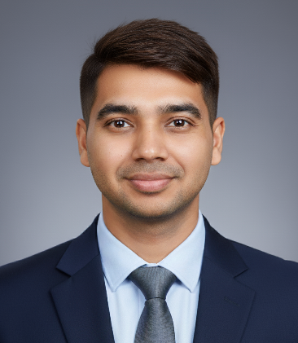
https://www.researchgate.net/profile/Dr_Shashi_Bhatia
http://scholar.google.co.kr/citations?user=xKOzI-wAAAAJ&hl=en
https://orcid.org/0000-0002-7688-6069

Professional profile
Dr. Shashi Kant Bhatia is working as an Associate Professor in the Department of Biological Engineering, Konkuk University, Seoul, South Korea. He received his M.Sc. and Ph.D. degrees in biotechnology from Himachal Pradesh University (India). Dr. Bhatia has worked as a Brain Pool Post Doc Fellow at Konkuk University (2014–2016), South Korea. His major research areas include environmental biotechnology, biochar production and applications in bioenergy and emerging contaminant removal, resource recovery from waste, valorizations of biowaste into biomaterials, bioenergy, and biochemicals, biotransformation and biocatalysis, fermentation, enzymes production, and immobilizations. He has published more than >250 research and review articles, edited 10 books, and holds 20 international patents. His current H-index is 72 with i10-index of 226, and citations of more than 18000. He is serving as an Editor-in-Chief in Biotechnology for Sustainable Materials and an Editorial board member of many international journals, including Biotechnology for Biofuel and Bioproducts, Microbial Cell Factories, Frontiers in Microbiology, Bioprocess and Biosystems Engineering, 3 Biotech, PLOS One, Sustainability, Energies, International Journal of Biomaterials, and Biomass, etc. He is also an active and regular reviewer of international journals published by Elsevier, ACS, Springer, Wiley, and Taylor & Francis publishers. He is listed in the world's top 2% of scientists for the years 2020 to 2025 as per a list published by Stanford University and a highly ranked scholar by ScholarGPS.

Education
Ph. D. (2007-2013) | Department of Biotechnology, Himachal Pradesh University, Shimla, India
M. Sc. (2005-2007) | Department of Biotechnology, Himachal Pradesh University, Shimla, India
B. Sc. (2002-2005) | Swami Vivekanand College, Ghumarwin, Himachal Pradesh, India

Career summary
Associate Professor (2020-2025)  Assistant Professor (2014-2020) | Konkuk University, South Korea  Konkuk University, South Korea
Post Doc position (2013-2014) | Konkuk University, South Korea

Declaration

I hereby declare that all the information given above is true to the best of my knowledge.
South Korea

Dec. 16th , 2025

